**🚀 AWS Elastic Load Balancer (ELB) Explained**

**🌐 What is an Elastic Load Balancer (ELB)?**

Amazon **Elastic Load Balancer (ELB)** is a fully managed AWS service that distributes incoming traffic across multiple targets (EC2 instances, containers, Lambda functions, etc.), ensuring **high availability, fault tolerance, and scalability**.

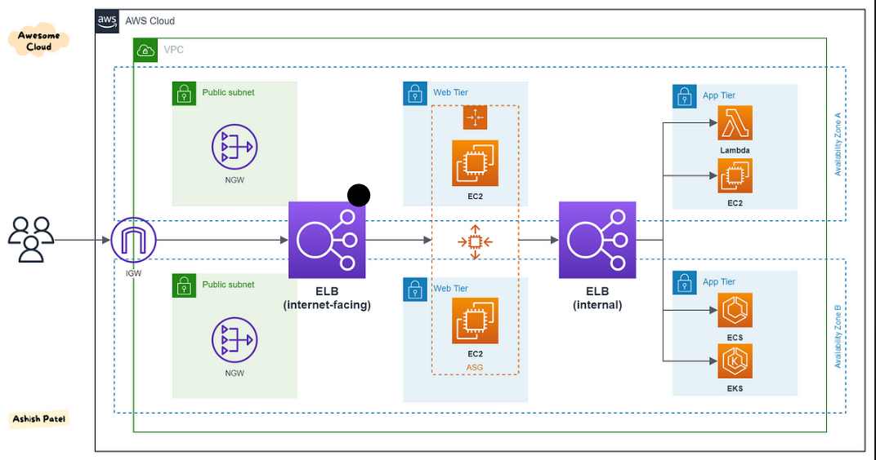

**🎯 Understanding Target Groups**

A **Target Group** is a collection of backend services that an ELB routes traffic to. Target groups allow flexible traffic management based on specific needs.

✅ **Supported Targets:**

* **EC2 Instances**
* **IP Addresses**
* **Lambda Functions**
* **Containers (ECS tasks, EKS pods)**

**🔄 How ELB Works with Target Groups (Example with EC2)**  
1️ **User requests a website via ELB's DNS name**  
2️ **ELB receives the request and checks listener rules** (e.g., path-based or host-based routing)  
3️ **ELB forwards the request to a target group** (containing EC2 instances)  
4️ **Health checks** are performed; unhealthy instances are bypassed  
5️ **EC2 instances process the request** and return the response via ELB

**🔥 Types of Elastic Load Balancers (ELB) & Real-time Use Cases**

**1️ Application Load Balancer (ALB) 🌍**

✅ **Layer:** **7 (Application Layer)**  
✅ **Best For:** Web applications, APIs, Microservices  
✅ **Key Features:**

* Path-based & Host-based routing
* SSL termination
* WebSocket support

📌 **Real-time Use Case:**  
Imagine an **e-commerce website** (www.shop.com).

* If a user visit www.shop.com/login, the ALB directs traffic to the **authentication service**.
* If a user visit www.shop.com/products, the ALB routes traffic to the **product catalog service**.
* ALB ensures that each request goes to the correct backend service based on the **URL path**.

**2️.Network Load Balancer (NLB) ⚡**

✅ **Layer:** **4 (Transport Layer - TCP/UDP)**  
✅ **Best For:** High-performance applications, real-time services  
✅ **Key Features:**

* **Handles millions of requests per second**
* **Low-latency** traffic routing
* **Supports static IP addresses**

📌 **Real-time Use Case:**  
Imagine a **stock trading platform** that needs to process buy/sell requests **in milliseconds**.

* The **NLB handles TCP traffic with ultra-low latency**.
* Traders get real-time updates on stock prices without delays.
* **Millions of concurrent users** can trade without performance issues.

**3️ Gateway Load Balancer (GWLB) 🔒**

✅ **Layer:** **3 (Network Layer - Security Focused)**  
✅ **Best For:** Security & Network Monitoring  
✅ **Key Features:**

* Load balances **firewalls, intrusion detection systems (IDS), and security appliances**
* Allows **traffic inspection between VPCs**

📌 **Real-time Use Case:**  
A **large enterprise** needs to inspect all incoming and outgoing traffic for security threats.

* **GWLB directs traffic to security appliances** like firewalls, IDS, and IPS before reaching internal applications.
* If **malicious traffic** is detected, it gets blocked before entering the corporate network.

**📊 Choosing the Right ELB**

| **ELB Type** | **Layer** | **Best For** | **Real-world Example** |
| --- | --- | --- | --- |
| **ALB** (Application Load Balancer) | Layer 7 | Web apps, APIs, microservices | Routing users to different services on an e-commerce site |
| **NLB** (Network Load Balancer) | Layer 4 | High-performance apps, gaming, trading | Real-time stock trading or multiplayer online gaming |
| **GWLB** (Gateway Load Balancer) | Layer 3 | Security appliances (firewalls, IDS/IPS) | Traffic inspection and filtering for a large enterprise |

**🎯 Final Thoughts**

* **Use ALB for web-based applications & APIs**
* **Use NLB for high-performance, low-latency applications**
* **Use GWLB for security appliances and network filtering**

|  |  |  |  |
| --- | --- | --- | --- |
| **ELB Type** | **Layer** | **Best For** | **Real-world Example** |
| **ALB** (Application Load Balancer) | Layer 7 | Web apps, APIs, microservices | Routing users to different services on an e-commerce site |
| **NLB** (Network Load Balancer) | Layer 4 | High-performance apps, gaming, trading | Real-time stock trading or multiplayer online gaming |
| **GWLB** (Gateway Load Balancer) | Layer 3 | Security appliances (firewalls, IDS/IPS) | Traffic inspection and filtering for a large enterprise |